Security Code Scan - static code analyzer for .NET

Hi All,

These are following steps that we have to follow to scan Vulnerable code and fix it in our project. It will be applying for all Microsoft applications (supporting language C# and VB.NET).

**Installation:**

First of all, we need to install security code scan (SCS) through NuGet package.

Option 01: Tools > NuGet Package Manager > Package Manager Console”. Run the command Get-Project -All | Install-Package SecurityCodeScan

Option 02: We can use “manage NuGet packages for solution”

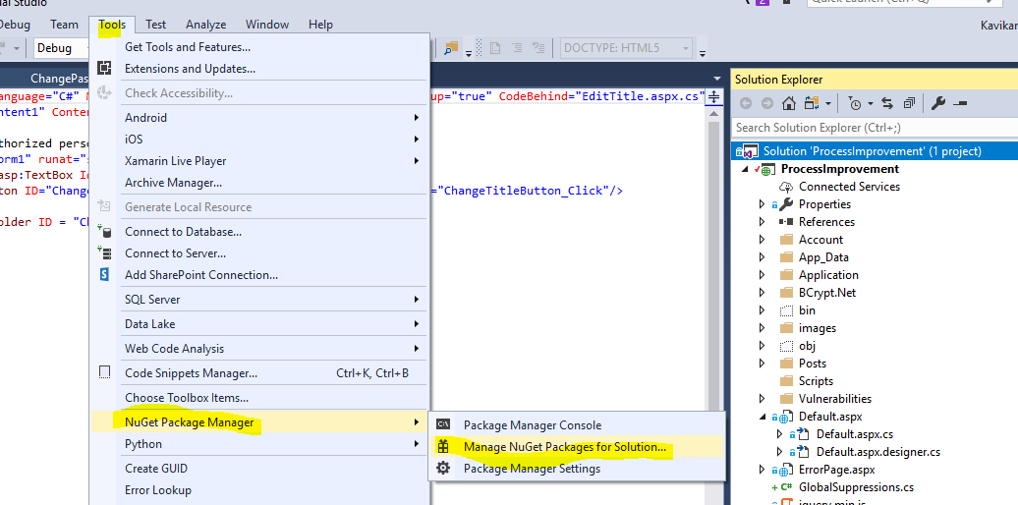

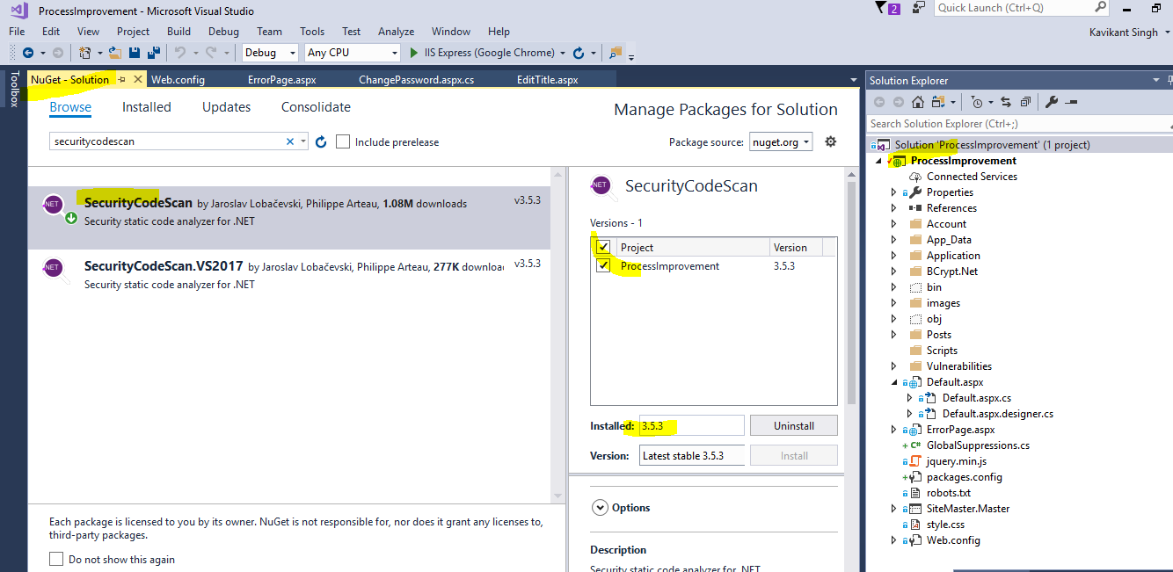

**Configuration:** Enable full solution analysis (please take a look the below mentioned screenshot)

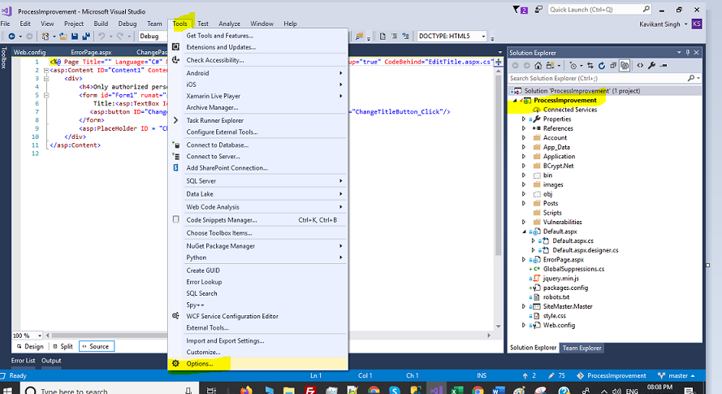

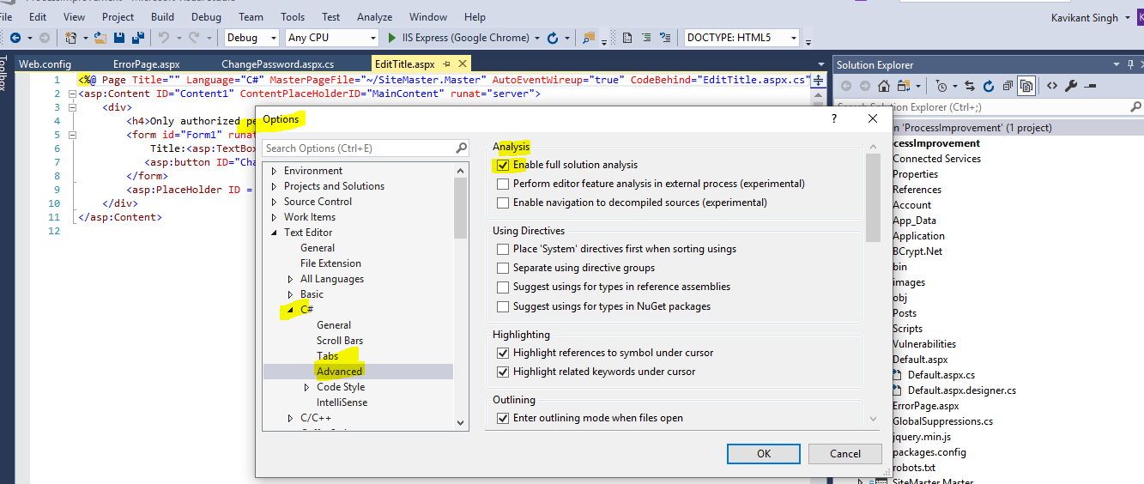

**Testing on Process Improvement (My Project Name):**

After completion of above steps, build your solution and open error list tab in your VS. As of now I have resolved issue of my code that’s why showing count as zero. You will get list of warnings.

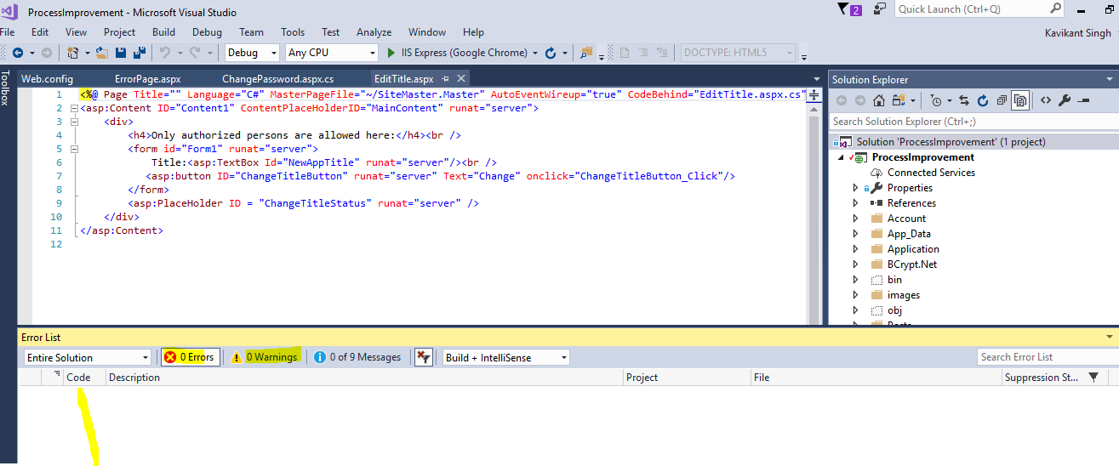

**Analyzing .aspx and web.config Files:**

We need to unload project and edit .csproj file and add below line like this.

<!-- Add the line below -->

<AdditionalFileItemNames>$(AdditionalFileItemNames);Content</AdditionalFileItemNames>

After added this line, reload project and re-build solution.

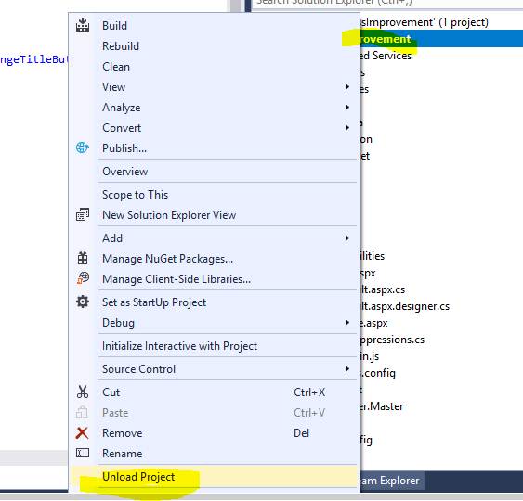

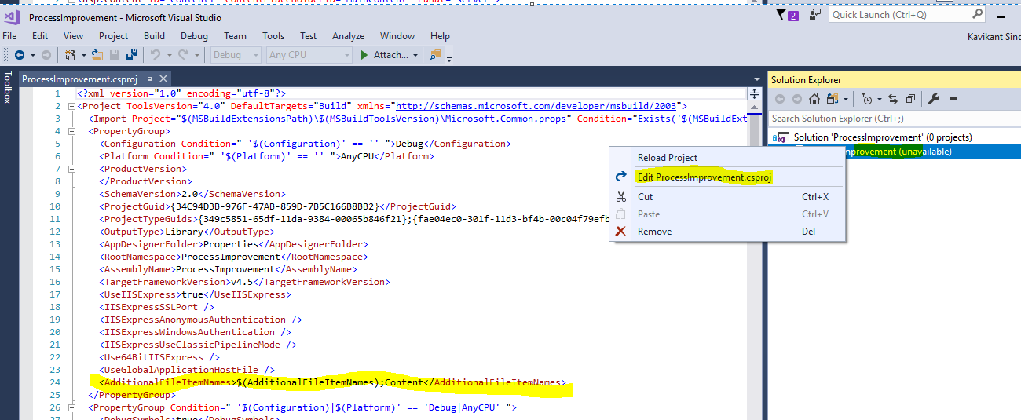

**Suppressing and Fixing the Warnings:**

Need to install System.Diagnostics.CodeAnalysis.dll for suppressing and fixing the warning.

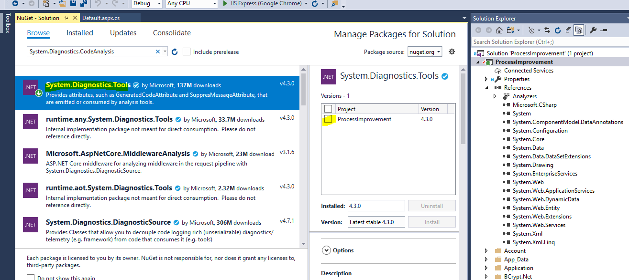

Once install above DLL, please run Analyse option and ‘Run Code Analysis and Suppress Active Issues’.

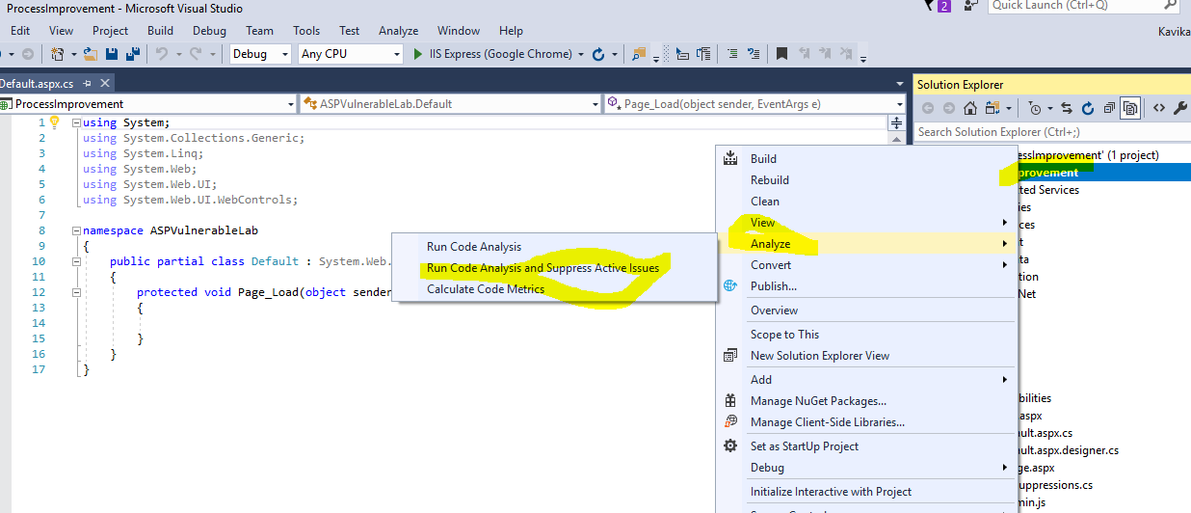

Then we can start and fix it like this

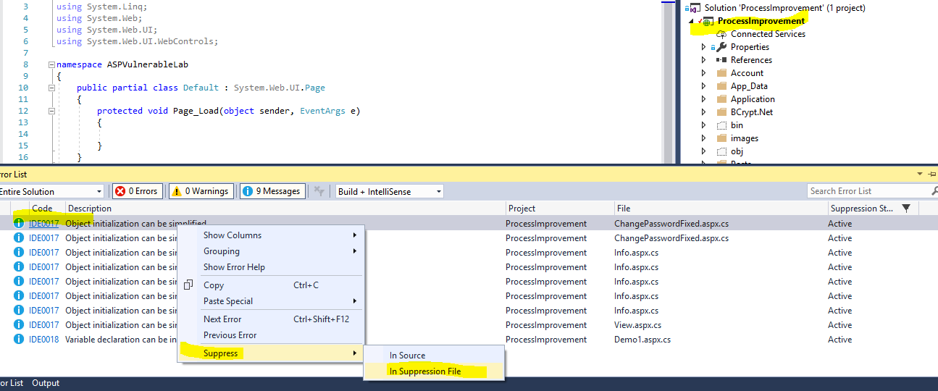

Then Press Apply button to remove info and warn messages.

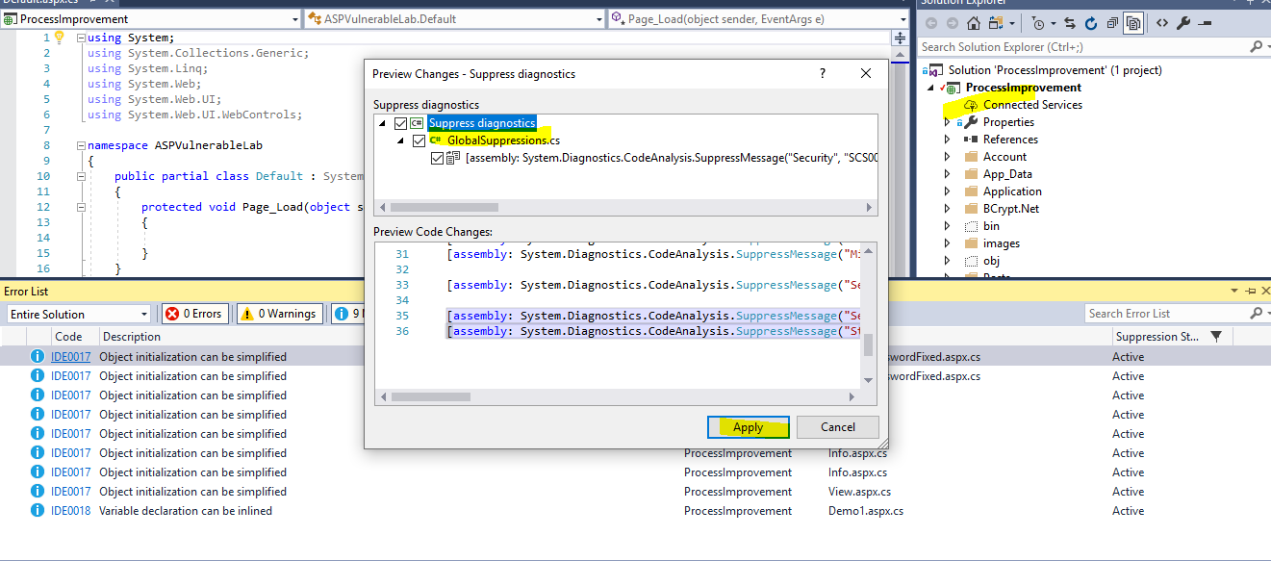

**Severity:** We can change severity of info/warn of error list tab.

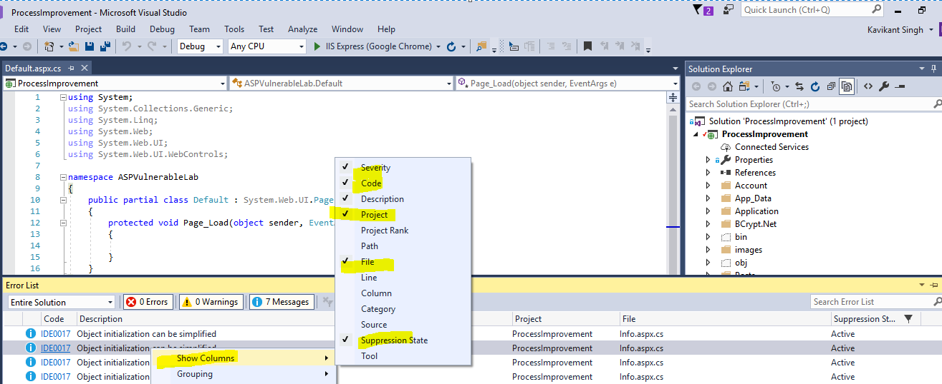

**Troubleshooting:** We will do troubleshooting if need furthers.

Thanks! Happy Coding 😊

Sapna Goyal